Andrew Hillard

Take Home Exam 2

April 18, 2016

**Problem 1**

a) Bayesian Learning is definitely going on as evident by the change in the prior and

posterior plots. See plots in all parts.

b) The credible set and HPDs are centered at smaller values as a and b increase. The HPD and credible set for each selection of a and b are close to each other.

c) For both analyses, the credible set and HPDs decrease and have a limit of 1 if a and b are equal and increase to positive infinity. The mean of the posterior decreases to 1 more quickly for accidents as a and b are increased since the sum(acc) is less than the sum(death).

d) The model is not robust to prior selection. The credible sets and HPDs change dramatically depending on the choice of the priors. See below as a and b are increased.

Model for Fatal Accidents, Yt

(a,b) = (1,1)



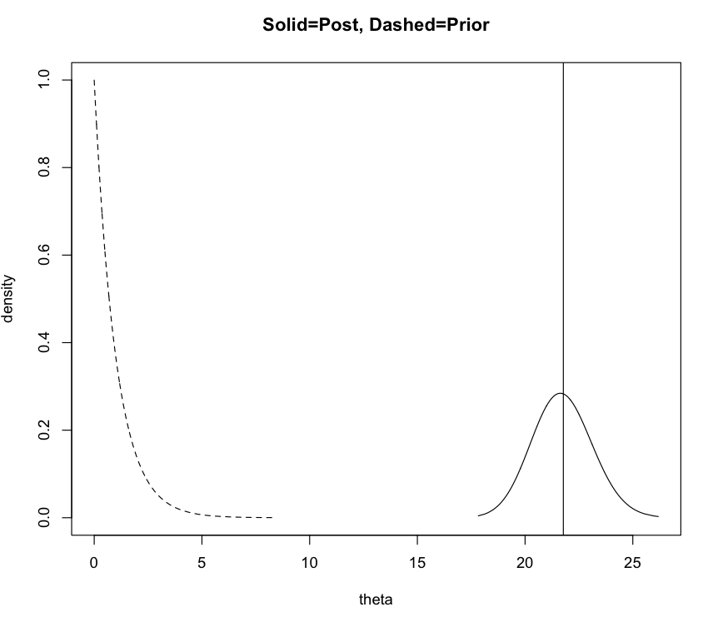

(a,b) = (10, 10)



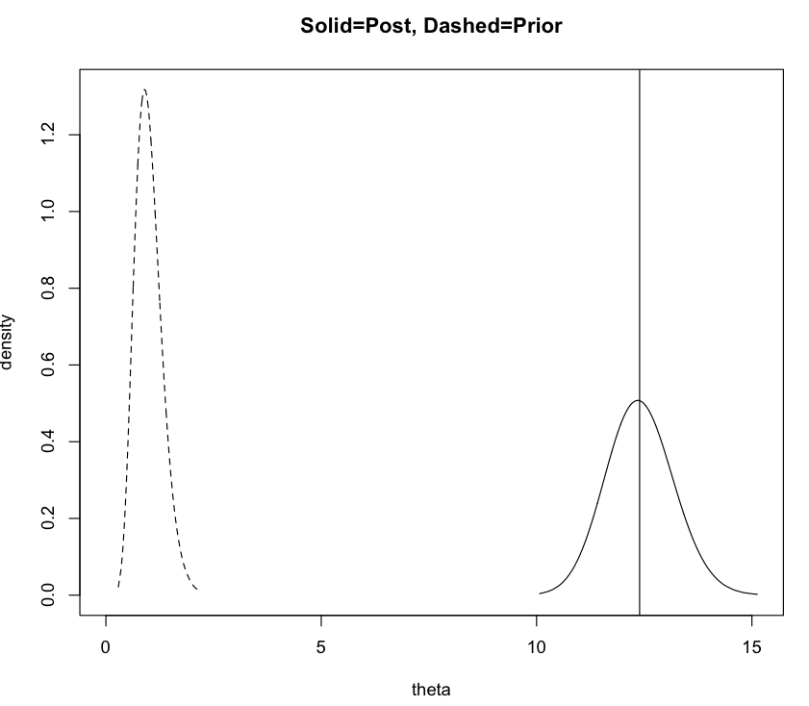

(a,b) = (100, 100)



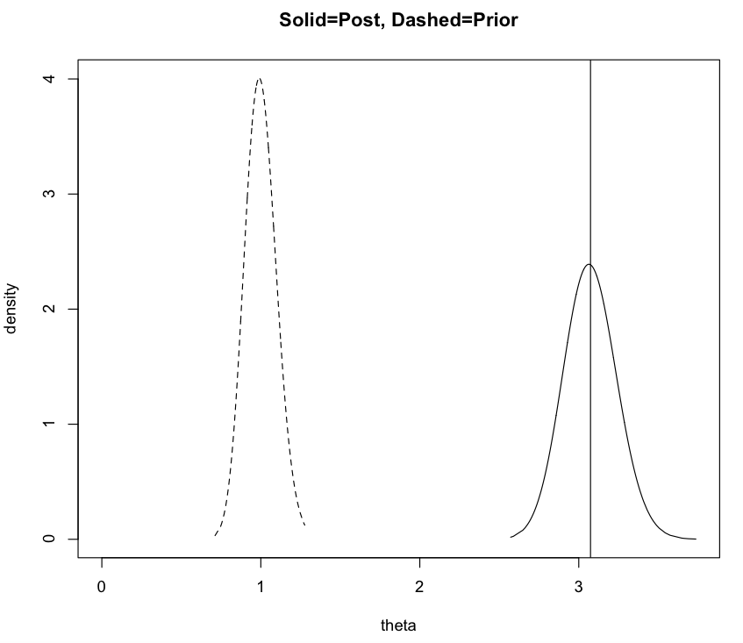

Model for Passenger Deaths, Xt

(a,b) = (1,1)



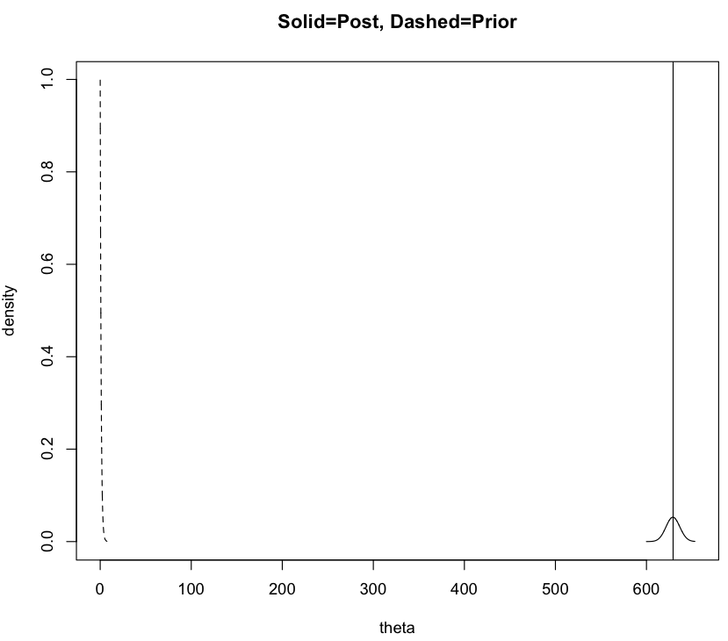

(a,b) = (10, 10)



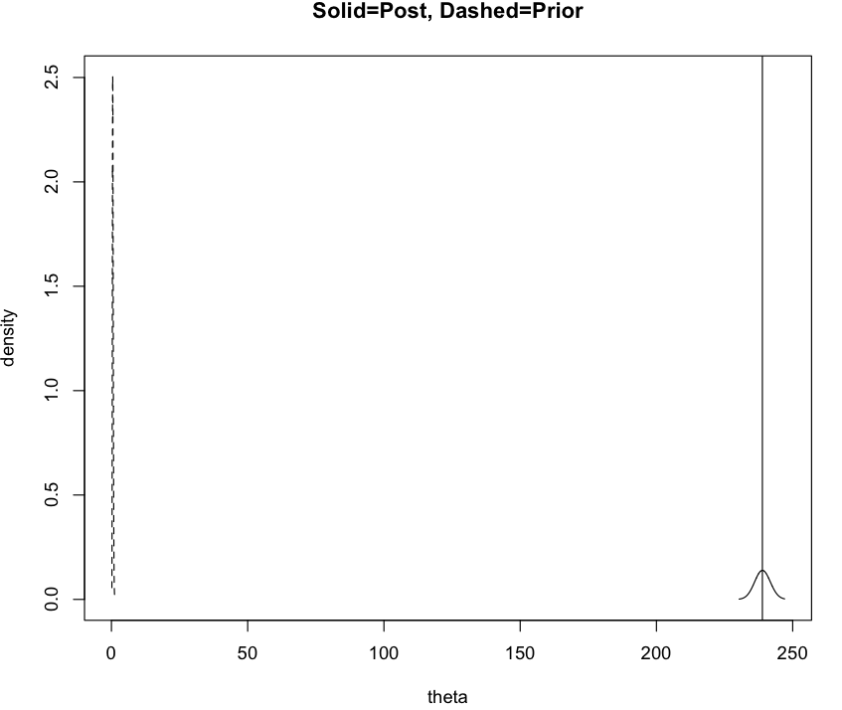

(a,b) = (100. 100)



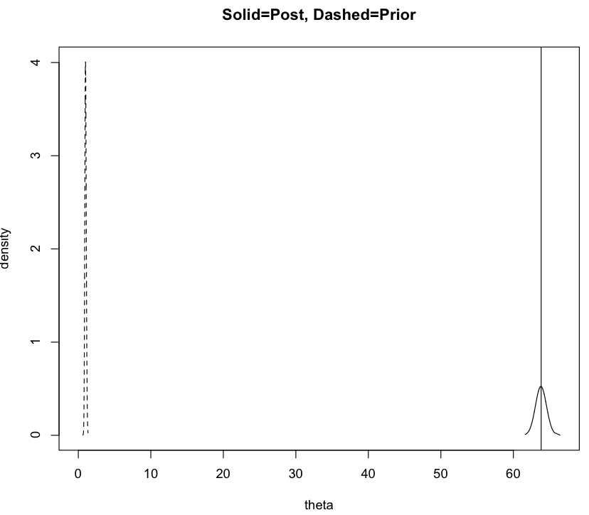

Problem 1 Part II)

Bayesian learning is going on in Part II and is dramatic; the posterior mean is significantly less than the prior mean. The credible sets and HPD across all selections of a and b are similar. The reason is because the sum(mi) is a lot greater than the sum(y), outweighing the effects of a and b in the posterior distribution. The analysis is therefore robust to the prior choice because the posterior distribution doesn’t change that much as a result of the selection of a and b.

(a,b) =(1,1)



HPD = [.003650399, .004720337]

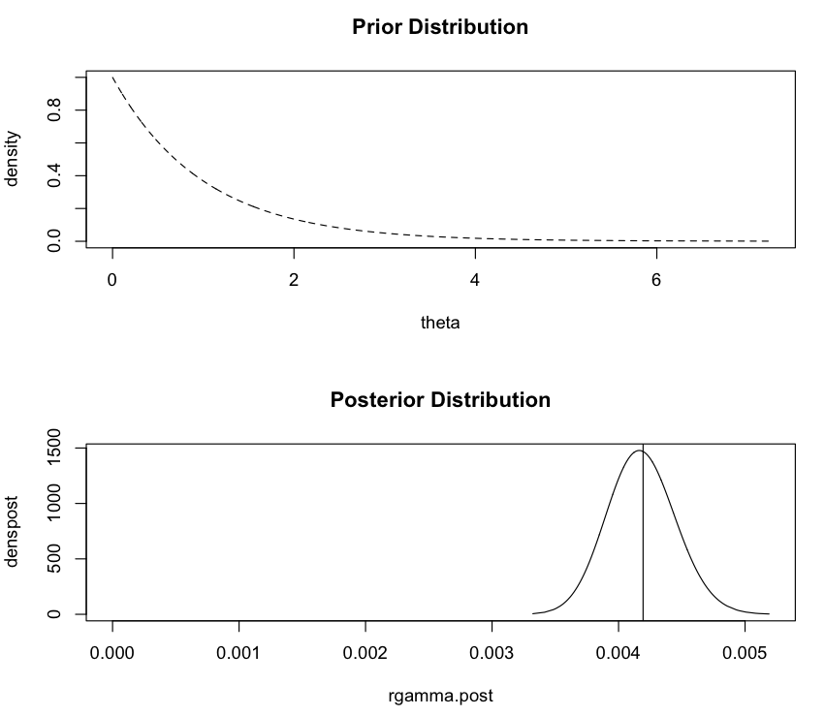

(a,b) = (10, 10)



HPD = [.003806957, .004886491]

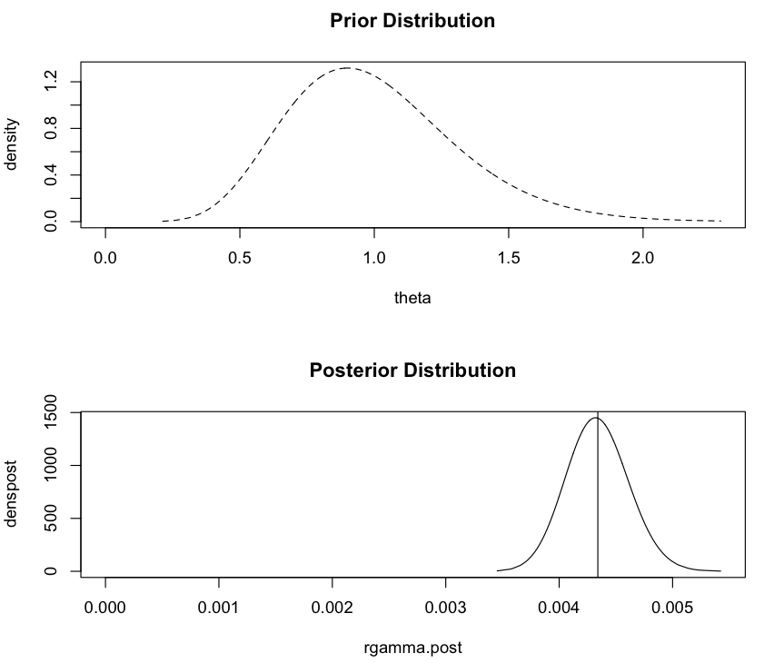

(a,b) = (100, 100)



HPD = [.005275119, .006539159]

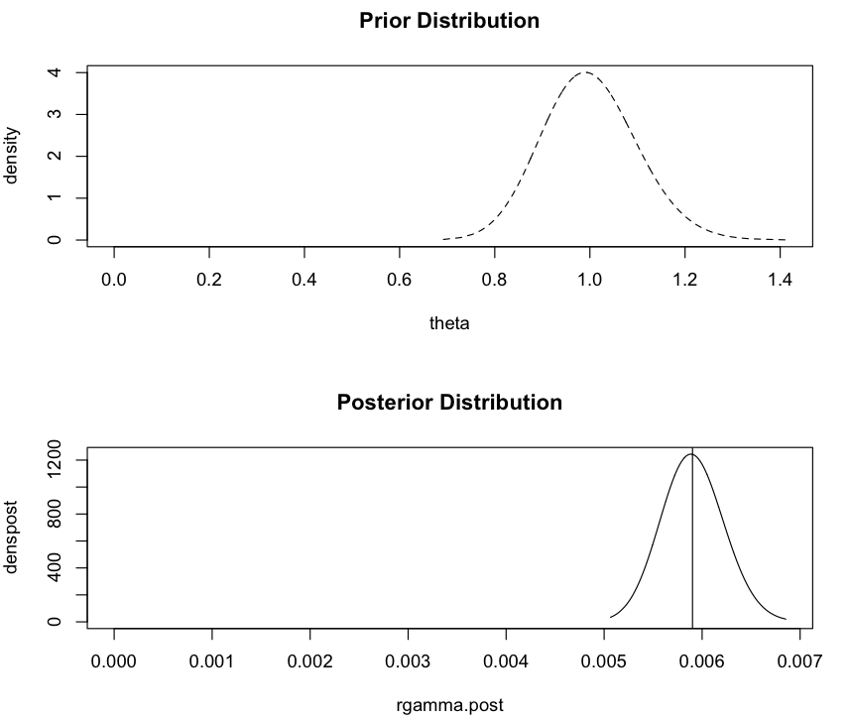

**Problem 2**



**Problem 3**

a) See function in R Code for sample of joint vector.

b) The marginal distribution of X is approximately normal with mean 10.53722016 and standard deviation 2.9707856308.

c) The credible sets contain the true values for both parameters.



d)

i. See R Code for rejection sampling function.

ii. The plot looks like what would be expected for a t-distribution, the mean of the plot is the mean of the sample and the distribution is symmetric.

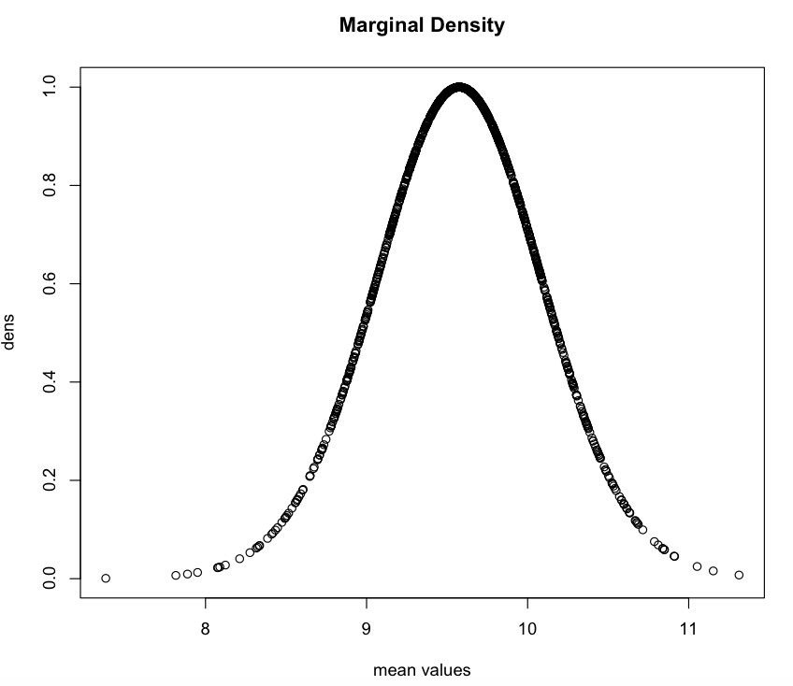

**Problem 4**

a) The probability that X is less than or equal to 5 is .00001, or approximately zero.



b) The probability that X is equal to 5 conditional on X being less than or equal to 5 is equal to 0.9257143.

**Problem 5**

a) See code.

b) E(N) = 2.71992 and Var(N) = 0.7634905. The mean is the natural number e.

**Problem 6**

a) See attached pdf titled Problem 6 Part a. The attachment has the derived posterior distribution and conditionals used for sampling in part b. The selected prior for theta is UNI(0, 1). The selected prior for lambda is GAM(alpha, beta). Alpha and beta for Gamma are estimated based on the mean and variance of the observed data – see code for alpha.est and beta.est.

b)



c) See code for simulation. Simulation is used as data for the posterior credible sets and means given in part b.

d) The marginal of y is an approximate ZIP distribution with mean 1.92271 and variance of 6.37672.

e) The predictive marginal distribution of y has an approximate ZIP distribution with mean equal to 2.96115 and variance 8.95558845. The plot of the distribution is given below as a bar chart for different counts of y simulated for 20,000 values.

**Predictive Distribution of Y given as Bar Plot**

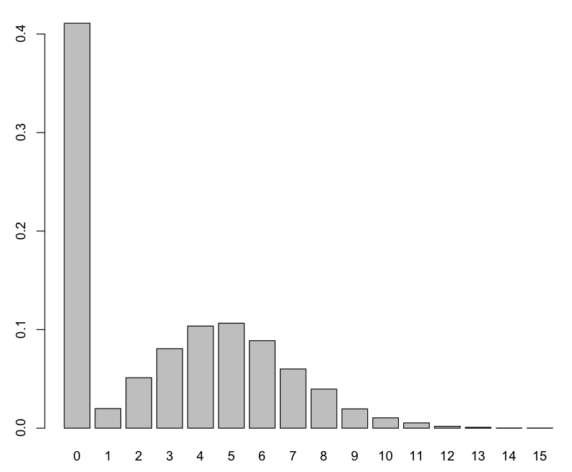

**Problem 7**

The approximate p-value is 0.776. Therefore, we fail to reject the null hypothesis and we can assume the sample is from the uniform distribution over the interval (50, 200).